Data Flow Diagram & User Stories

|  |  |
| --- | --- |
| Team ID | PNT2022TMID45954 |
| Project Name | Machine Learning-Based Predictive  Analytics for Aircraft Engine |
| Maximum Marks | 4 Marks |

# Data Flow Diagrams:

A Data Flow Diagram (DFD) is a traditional visual representation of the information flows within a system. A neat and clear DFD can depict the right amount of the system requirement graphically. It shows how data enters and leaves the system, what changes the information, and where data is stored.

EXAMPLE: **Data flow diagram for Machine Learning-Based Predictive Analytics for Aircraft Engine**

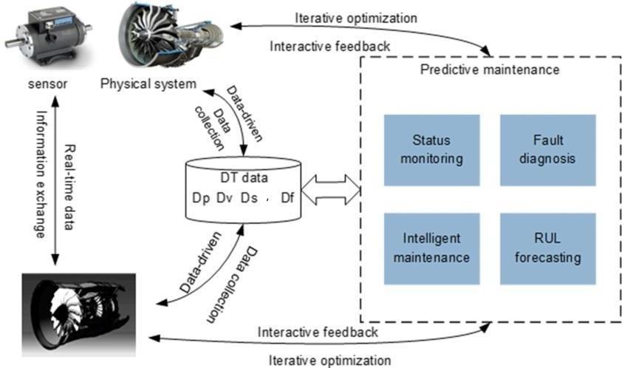

**DT-Data technology**

# DP-Data Processing DV-Data visualization DS-Data Server

**User Stories**

Use the below template to list all the user stories for the product.

|  |  |  |  |  |  |  |
| --- | --- | --- | --- | --- | --- | --- |
| **User Type** | **Functional Requirement**  **(Epic)** | **User Story Number** | **User Story / Task** | **Acceptance criteria** | **Priority** | **Release** |
| Customer (Mobile user) | Registration | USN-1 | As a user, I can register for the application by  entering my email, password, and confirming my password. | I can access my account / dashboard | High | Sprint-1 |
|  |  | USN-2 | As a user, I will receive confirmation email  once I have registered for the application | I can receive confirmation  email & click confirm | High | Sprint-1 |
|  |  | USN-3 | As a user, I can register for the application through Facebook | I can register & access the dashboard with Facebook  Login | Low | Sprint-2 |
|  |  | USN-4 | As a user, I can register for the application  through Gmail | I can access the  application through mail | Medium | Sprint-1 |
|  | Login | USN-5 | As a user, I can log into the application by  entering email & password |  | High | Sprint-1 |
|  | Dashboard | USN-1 | As a user, I can search my requirements |  |  |  |
| Customer (Web user) | Registration | USN-1 | As a user, I can register for the application by entering my email, password, and confirming  my password | I can access my account / dashboard | High | Sprint-1 |
|  |  | USN-2 | As a user, I will receive confirmation email  once I have registered for the application | I can receive confirmation  email & click confirm | High | Sprint-1 |

|  |  |  |  |  |  |  |
| --- | --- | --- | --- | --- | --- | --- |
| **User Type** | **Functional Requirement**  **(Epic)** | **User Story**  **Number** | **User Story / Task** | **Acceptance criteria** | **Priority** | **Release** |
|  |  | USN-3 | As a user, I can register for the application through Facebook | I can register & access the dashboard with Facebook  Login | Low | Sprint-2 |
|  |  | USN-4 | As a user, I can register for the application  through Facebook | I can access the  application through mail | Medium | Sprint-1 |
| customer web  verification | Captcha | USN-1 | As a user, by clicking the correct pictures of  the given puzzles | By clicking the puzzles  can log in page | low | Sprint-2 |
| Customer Care Executive | User issue | USN-1 | If the users facing any issue, user can contact customer care executive | Customer care executive will solve the users  requirements. | Medium |  |
| Administrator | Checking user security and  requirements | USN-1 | when user facing any security issue | Administrator will solve the user’s requirements | High |  |
|  | Monitoring the  user’s verifications | USN-2 | when users verify through email, captcha | Administrator will monitor  the verification stage issue | High |  |